AIRN@V2 - MSN4
Prerequisites:
- SWS application.
- IE web browser installed In your system.
- Jre is installed in your system.
- The configuration below are done on the Domain table:
+ The program 'W' is not assigned to the variable 'QA10_AIRNAV_PROG_V3'.
+ The 'Low Value' of the variable 'QA10_AIRNAV_MSN' is 'N'.
Steps:
- Open the Item List screen of an A300 logbook.
- Click on the Airn@v button '@'.
- Open the Item Detail screen of an item, then click on the Airn@v button '@'.
- Close the IE web browser. From the Item Detail screen, click on the 'TroubleShooting Manual access' button.
Expected results:
2. 3. 4.
>> The IE web browser is launched.
>> Check that the logbook's MSN value appears on the URL on 4 digits. (Example: 0002).
Actual results:
2. OK for the URL, but sometimes, two browsers are launched.
3. OK.
4. The MSN value appears on 5digits
http://psp-awn-01:9091/awn/defaultgui/servlet/ServiceDispatcher??AWN_ClientType=default&module=kernel&service=externalConnect&args=customerName$$Airbus||customerPassword$$airbus||groupName$$User||groupPassword$$||userName$$inorSQLI-BJNYH5J||force$$true||baseName$$A300||baseRevDate$$||baseCustom$$TEA||serviceName$$AirN@v%20Maintenance||serviceMSN$$||effect$$00002||effectType$$MSN||linkType$$doc||linkDoc$$@ATSP||linkAccess$$service=selectFirstEP

AIRN@V3 - MSN4
Prerequisites:
- SWS application.
- IE web browser installed In your system.
- Jre is installed in your system.
- The configuration below are done on the Domain table:
+ The program 'P' is assigned to the variable 'QA10_AIRNAV_PROG_V3'.
+ The 'Low Value' of the variable ' QA10_AIRNAV_V3_MSN' is 'N'.
Steps:
- Open the Item List screen of an A350 logbook.
- Click on the Airn@v button '@', then check the content of the file 'TLBApplicationFolder\NewTLB_Release\Working\XXXXXXX.init'.
- Open the Item Detail screen of an item, then click on the Airn@v button '@'. Check the content of the file 'TLBApplicationFolder\NewTLB_Release\Working\YYYYYYYY.init'.
- From the Item Detail screen, click on the 'TroubleShooting Manual access' button, then check the content of the file 'TLBApplicationFolder\NewTLB_Release\Working\ZZZZZZZZZ.init'..
Expected results:
2. 3. 4. The 'msnbr' value contains the Logbook's MSN value on 4 digits.
Actual results:
2. 3. 4. The MSN value appears on 5 digits.
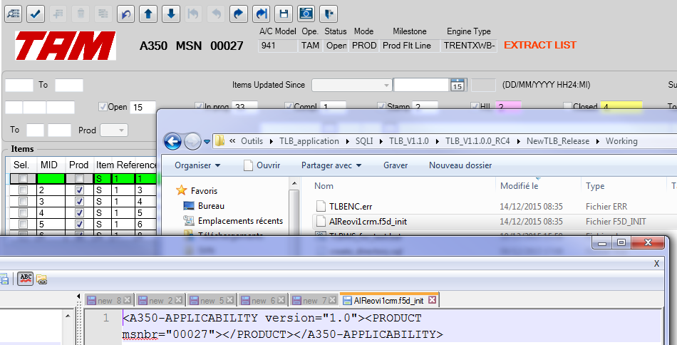

ONTS / NRCT - MSN4
Prerequisites:
- SWS application.
- IE web browser installed In your system.
- The configuration below are done on the Domain table:
The 'Low Value' of the variable 'QA10_ONTS_MSN' is 'N'.
Steps:
- From a SWS, open an opened logbook.
- Create an item.
- Click on the "ONTS" button.
Expected results:
3.
>> The IE web browser is launched with the URL below:
http://<server>:<port>/FV80/tlbLink.xhtml?program=<program>&msn=<msn>&tlbCheck=<tlbCheck>&tlbSequence=<tlbSequence>&tlbItem=<tlbItem>
>> Check that the <msn> value is composed of 4 digits.
Actual results:
3. The MSN value appears on 5digits
http://onts-v.eu-v.airbus-v.corp/FV80/tlbLink.xhtml?program=SA&msn=00029&tlbCheck=S&tlbSequence=1&tlbItem=0

Added from smb twice 3th 4th

